MITCH-Clim v0.1

User Guide

*Model-based Insights into Tortoise Critical Habitat under Climate Change*

Authors: Kevin Shoemaker, Elizabeth Hunter, Kevin Loope, Michael Lam

Last Modified 7/3/2023

***Table of Contents***

Preface 3

Introduction 3

Purpose 3

Accessibility 4

Application 4

Quick Start Guide 5

Loading Scenarios (Step 1) 6

Selecting Inputs 6

Activate Climate Effects on Tortoise Vital Rates: 7

Climate Scenarios: 7

Choosing a Region of Interest (Step 2) 8

Method 1 - Drawing a polygon 8

Method 2 - Selecting a polygon from dropdown menu 10

Method 3 - Uploading a polygon from file 10

Analysis (Step 3) 11

Understanding the Outputs 12

Abundance over Time (Current Run) 12

Abundance over Time by Age Structure 13

Abundance over Time (Scenario Comparison) 13

Abundance Map 14

Downloading Results 15

Starting New Analyses 15

# Preface

## Introduction

Conserving threatened and endangered species (TES) on Department of Defense (DoD) installations, without sacrificing vital military objectives, is necessarily a complex balancing act – especially given the uncertainties and risks associated with climate change.

This project advances the concept of critical habitat breadth as the foundation for rigorous TES conservation planning and vulnerability assessment in the face of climate change. In this application we apply the critical habitat breadth concept to the Desert Tortoise (*Gopherus agassizii*) to understand and predict the range of climate conditions capable of harboring viable populations of this species now and in the future.

We compiled and re-analyzed previously collected data from across the range of the Desert Tortoise to assess how Desert Tortoise demographic vital rates (e.g., survival, fecundity, age-at-maturity) respond to spatiotemporal environmental and climatic gradients. In addition, we conducted intensive nest monitoring surveys to investigate how hatching success and hatchling sex ratios respond to climate gradients. We integrated these statistical models into comprehensive, spatially explicit predictive models capable of forecasting annual range-wide population dynamics for both species. We used this simulation model to forecast and visualize population dynamics through the year 2099 under multiple plausible scenarios, and to predict when and where populations are most likely to be self-sustaining.

## Purpose

The main purpose of this application is to assist resource managers in identifying mitigation and conservation strategies capable of sustaining viable Desert Tortoise metapopulations under changing and uncertain future climate conditions. This application allows the user to select a scenario and define a region of interest within the Desert Tortoise range and the application provides detailed information on projected spatiotemporal population dynamics. The application also allows users to compare expected conservation outlooks under multiple scenarios.

The sections below provide detailed instructions on how to utilize this application.

# Accessibility

The MITCH-Clim v0.1 application is hosted on shinyapps.io: <https://kevintshoemaker.shinyapps.io/Mitch-clim_v01/>, and also available for download through [GitHub](https://github.com/kevintshoemaker/GopherusPVA).

If using the PC version downloaded from GitHub, user must also have R and RStudio downloaded to run the application:

* Open the App.R file in the RStudio integrated development environment (IDE). App.R is located in the DTApp folder within the MitchClim_v01 folder in GitHub.
* RStudio should automatically search for and ask the user to download any package dependencies upon opening of App.R. Make sure all required packages are installed prior to running the application.
* Click on ‘Run App’ on the top right of the RStudio environment.

# Application

Instructions on how to use the application can also be found in the default ‘Overview’ tab of the application itself.

## Quick Start Guide

1. At top of navigation panel, click on the 'Application' tab

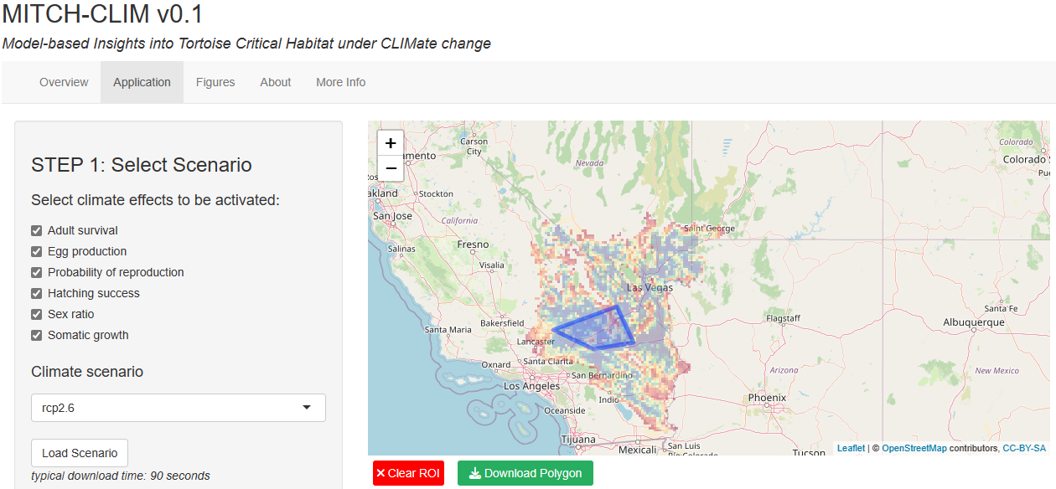

1. Select vital rates to activate (all boxes checked means that each of the six vital rates are allowed to change across space and time as a function of climate, in turn driving Desert Tortoise abundance)
2. Choose one of the four climate scenarios (RCP2.6, RCP4.5, RCP6.0, or RCP8.5)
3. Load scenario (unique vital rate x RCP combination) by clicking the ‘Load Scenario’ button
4. Choose an ROI (region of interest) using one of three methods
   1. Draw polygon directly on interactive map window
   2. Select polygon from pre-set list
   3. Upload polygon from file (ESRI Shapefile format)
5. Click on the 'Run Analysis' button (takes two minutes or longer to process)
6. Click on the 'Output Viewer' tab to display results (tab displays after analysis is complete)
7. Load additional scenarios (Application tab) to compare by re-running the above steps

## Loading Scenarios (Step 1)

### Selecting Inputs

First, the user can use the checkbox interface (see below) to indicate which Desert Tortoise population vital rates, if any, they wish to model as a function of climate. The default scenario is for all vital rates to respond to climate: since all climate-vital rate relationships were fitted empirically, we consider this condition to be the most realistic. Next, use the dropdown menu to select which RCP scenario to include in the analysis. See next section below for what each variable represents.

Once all scenario inputs are selected, click on the 'Load Scenario' button to begin downloading simulation results from the cloud. The loading process takes about 60-90 seconds.

A progress bar will appear in the bottom right of the screen, saying ‘Download in Progress’. Once completed, the message ‘Your selected scenario has been successfully downloaded!’ will appear on the screen.

### Activate Climate Effects on Tortoise Vital Rates:

**Six key Desert Tortoise vital rates can be modeled as a function of climate:**

**Adult survival**: This parameter represents the annual survival rate for all reproductive adults (individuals above the age-at-maturity). Modeled using data from existing capture-mark-recapture and telemetry data, and published literature.

**Egg production**: This parameter was measured as the total annual per-capita egg production, also known as clutch size. Modeled using data from diagnostic imaging technology, and telemetry.

**Probabability of reproduction**: This parameter was drawn directly from our range-wide analysis of Desert Tortoise reproductive output. Modeled using data from diagnostic imaging technology, and telemetry.

**Hatching success**: This parameter represents the fraction of eggs within each nest that hatch successfully, assuming the nest does not fall victim to predation. Modeled using data from nest site monitoring.

**Sex ratio**: The sex ratio parameter (proportion of hatchlings born female; PF) reflects the fraction of successful hatchlings in each nest that are born female. Since this species has temperature-dependent sex determination, this parameter was modeled as a function of temperature, using data from nest site monitoring and hormone assays.

**Somatic growth**: This parameter represents growth by age as modeled using the von Bertalanffy growth function, involving a growth coefficient *k* and an asymptotic body size coefficient *a*. Both coefficients are modeled separately as a function of climate. Modeled using data from diagnostic imaging technology, and morphometrics.

### Climate Scenarios:

The Representative Concentration Pathways (RCPs) describe four different 21st century pathways of greenhouse gas (GHG) emissions and atmospheric concentrations, air pollutant emissions and land use.

**RCP 2.6**: This scenario aims to keep global warming likely below 2°C above pre-industrial temperatures. This is the most stringent of the scenarios.

**RCP 4.5**: This intermediate scenario assumes a consistent decrease in emissions as a consequence of assumed air pollution control and GHG mitigation policy. More likely than not to exceed 2°C temperature increase by end of the 21st century.

**RCP 6.0**: This intermediate scenario assumes a consistent decrease in emissions as a consequence of assumed air pollution control and GHG mitigation policy. Likely to exceed 2°C temperature increase by end of the 21st century.

**RCP 8.5**: This 'baseline' scenario follows higher GHG emissions compared to the other three scenarios.

## Choosing a Region of Interest (Step 2)

In this study, each cell/pixel represents a 5 X 5 km grid area.

There are three ways in which the user can select an ROI. Note that only one region of interest is stored at any given time.

### Method 1 - Drawing a polygon

1. Click inside the Map box to initiate first vertex of polygon. If you make a wrong vertex at any point, click on 'Clear ROI' to start over.
2. A vertex will be created where 'clicked' and a message a will appear. You can click on the “X” button in the top righthand corner of the pop-up window to clear it from the screen.

1. Click on a second location in the Map box to draw a second vertex. A blue line connecting these two points will now display.

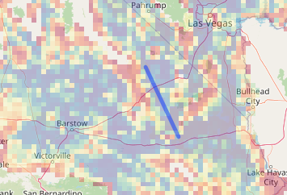

1. Continue to add vertices to your polygon until you have a least 4 vertices.

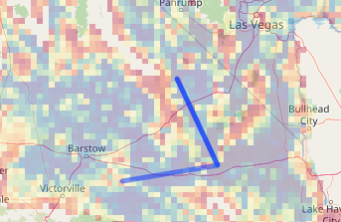

1. Your polygon should now be a closed figure with the last line/vertex connected back to your first vertex. You can continue to add as many vertices as you would like to define your region of interest.

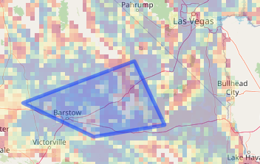

### Method 2 - Selecting a polygon from dropdown menu

1. Click on dropdown menu

1. Select the desired preset DoD installation site (Note that this menu lists only the DoD sites that overlap with the desert tortoise range).
2. The chosen DoD site polygon will automatically generate on the map.

### Method 3 - Uploading a polygon from file

1. This must be an associated set of polygon files in the form of a shape files, with file extensions .dbf, .prj, .shp, and .shx.
2. Select all four file components together and then click ok.
3. A popup should then appear in a second to confirm that the file selected has been successfully downloaded.
4. The polygon should automatically render onto the map.

NOTE you can download the current polygon (regardless of how it was generated) to your computer by clicking the green 'Download Polygon' button under the Map box.



Once an ROI is made, you may proceed to 'Run Analysis' (if scenario already downloaded). Clicking on the “Clear ROI” button will start a new polygon of interest.

## Analysis (Step 3)

*Upon clicking the 'Run Analysis' button, a popup message on the bottom right should appear saying 'processing started'.*

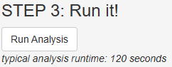

*Please wait for the duration for the analysis to run (this typically takes 2-4 minutes).*

*A second message will appear once the analysis is complete. A new tab called 'Output Viewer' will appear next to the 'Application' tab. Click on this tab.*

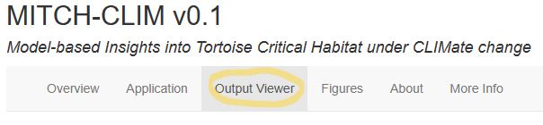

## Understanding the Outputs

The analysis process automatically clips the portion of the ROI that is within the boundaries of the desert tortoise range and runs the analysis for both the ROI as well as the full desert tortoise range extent. Each output tab will display results for both ROI and full range. If no ROI has been specified, the full range is used as the ROI and there should be no difference between the ROI and full range outputs.

The ‘Output Viewer’ tab contains several results panels which display the following:

* Current Run -- Plot of final abundance for ROI vs Full Range for the most recently run scenario
* Age Structure -- Plot of final abundance broken down by age structure (hatchling, juvenile, and adult stages) of ROI vs Full Range of user-selected scenarios for comparison
* Comparison -- Plot output of ROI vs all user-selected scenarios run during this session (enabling comparison of multiple scenarios)
* Map -- Map output of ROI vs Full Range of user-selected scenarios for comparison

### Abundance over Time (Current Run)

The default tab in the Output Viewer page tab is the ‘Current Run’ tab, which plots the 20 replicates of abundance (by the thousands) by year from 2010 to 2099. The dark line represents the median replicate abundance. Note the scales can differ in the left Y axis between the ROI and full range.

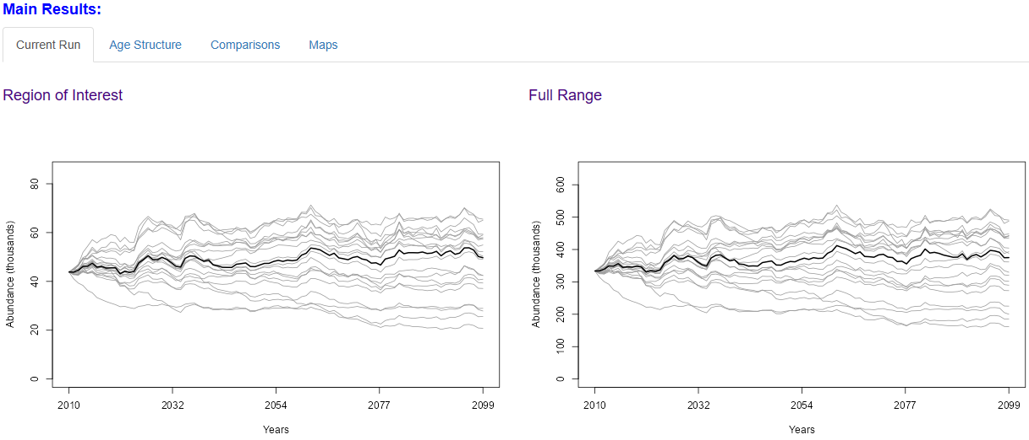

### Abundance over Time by Age Structure

The second tab in Output Viewer displays the same results from the ‘Current Run’ tab, but broken down by the three primary tortoise age groups (hatchling, juvenile, and adult). As you can see in the example below, the majority of the desert tortoise population tends to be in the juvenile phase (it takes many years to reach adulthood). Again, note the scales can differ in the left Y axis between the ROI and full range.

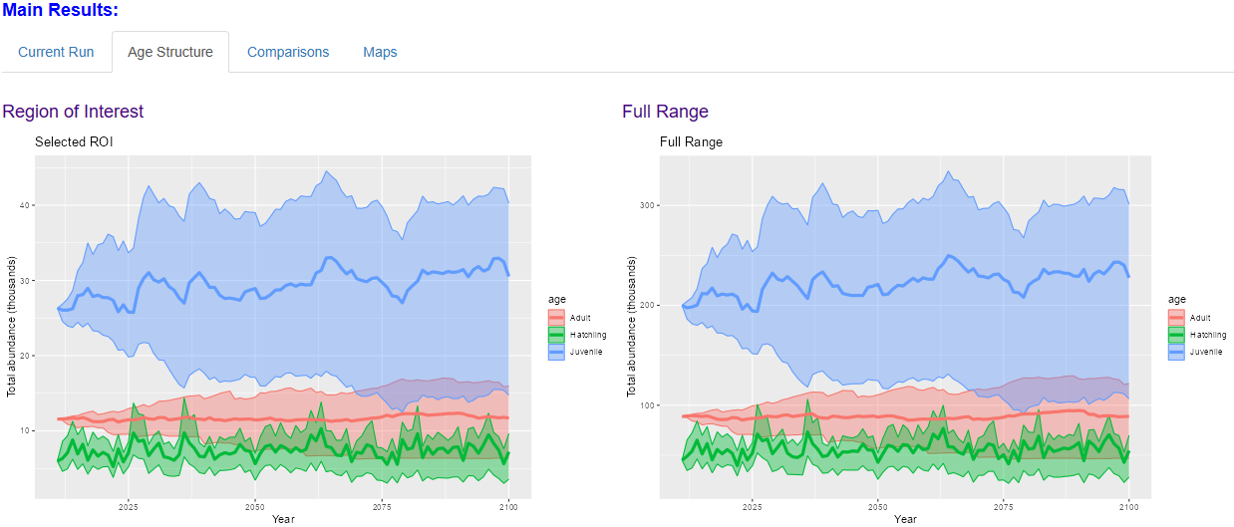

### Abundance over Time (Scenario Comparison)

The third tab in Output Viewer allows you to check from a list of previously loaded scenarios in this open session of the application to display. It will show the current/recent ROI data on the left, and the full range on the right, as usual.

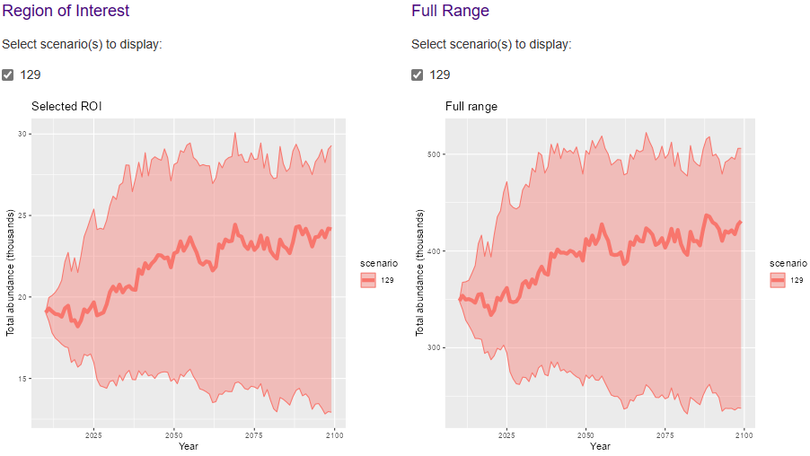

You will be able to check on/off which scenarios to display. Please use the accompanied chart on the top portion of the tab to remember what parameter settings each scenario index (right-most column in the table that appears at the top of the scenario comparison tab) corresponds to:



phi.a_clim = Adult survival

cs_clim = Egg production

pr_clim = Probability of reproduction

hs_clim = Hatching success

pf_clim = Sex ratio

growth_clim = Somatic growth

clim_scenario = Climate scenario

‘TRUE’ signifies that the parameter was toggled ‘on’, meaning that it is impacted by climate factors.

‘FALSE’ signifies that the parameter was toggles ‘off’, meaning that it is NOT impacted by climate factors.

### Abundance Map

The fourth and final tab in the output viewer allows the user to select the year and percentile of abundance to display spatially, both for the selected ROI (left map) and the full range (right map). Drag the slider bar to select a specific simulation year and a specific abundance percentile to display. You may also use the play button located on the right-hand side of the simulation year to automatically load the next year’s results every 5 seconds. Note that the results take some time to process and refresh for each new year displayed.

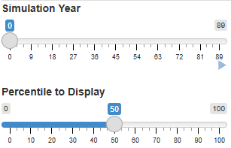

X (bottom) and Y (left) axes show the geographic coordinates, while legend (color ramp) indicates the total population abundance in each pixel:

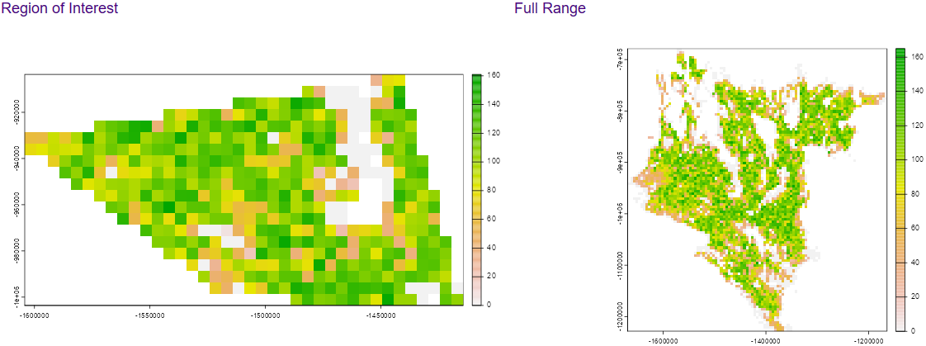

## Downloading Results

*Users will be able to download the maps and/or plots individually to their own device as a Tif file. Users will also be able to download any current selected polygon ROI as a shapefile, which can be reuploaded in future app sessions to run more analyses.* [NOTE: this feature has not yet been implemented as of 7/3/2023]

## Starting New Analyses

* *To begin a new analysis, click back to the 'Application' tab*
* *Click on the red 'Clear ROI' button located under the Map panel*

**

* *This will get rid of the polygon(s) as well as clear any tables and maps displayed in the results area (Output Viewer tab)*